 [Translated from Arabic to English - www.onlinedoctranslator.com](https://www.onlinedoctranslator.com/en/?utm_source=onlinedoctranslator&utm_medium=docx&utm_campaign=attribution)

**car design WRO Future Engineer**

One of the ready-made cars containing two electric motors was used according to the competition criteria as follows:

* Rear primary electric motor to drive the vehicle (rear two-wheel drive) as shown in Illustration 1
* Front electric motor to control the direction of the vehicle as shown in the illustration 2

electric motor

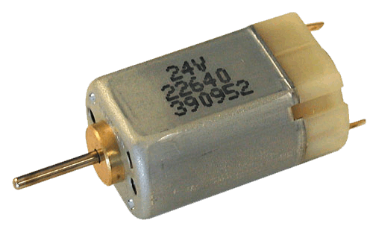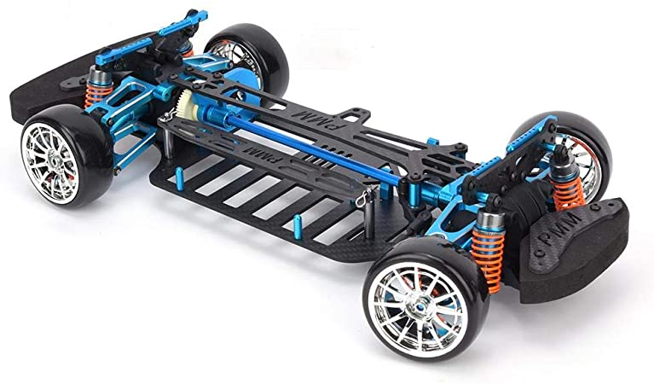 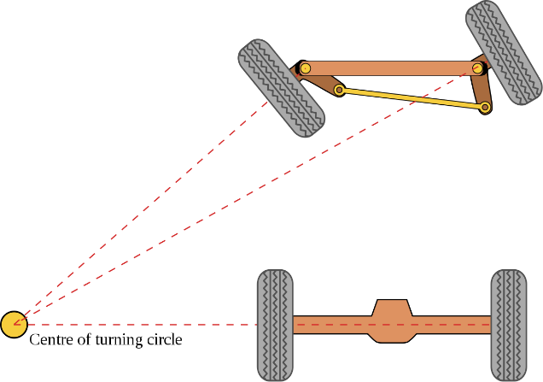

Illustration 1 Illustration 2

The outer cover of the car was dispensed with, and some elements were designed and 3D-printed and installed on the base of the car. The elements that were designed are:

* device holder Raspberry Pi
* camera holder for Raspberry Pi
* Rechargeable battery holder and variable battery
* A picture containing diagram

  Description automatically generateddevice holder H-bridge